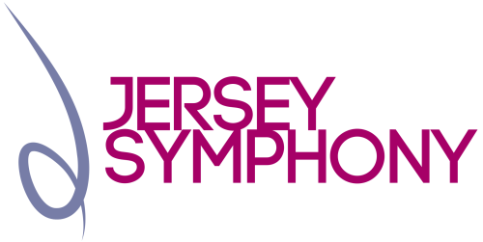

FRIENDS OF THE ORCHESTRA
If you would like to become involved in the activities of the Jersey Symphony Orchestra Association and help promote and support the Orchestra, you can become a ‘Friend of the Orchestra’ at an annual cost of £25.00 single and £45.00 joint, minimum donation. In return for your subscription you will receive concert newsletters and a priority booking period during which to buy tickets.
If you would like further information, please contact Carol Preston, Membership Secretary, phone 864127 or email jso1987@yahoo.co.uk. Otherwise, complete the application form and send it, either with a cheque made out to Jersey Symphony Orchestra Association or with the banker’s order below, to JSO Friends’ Membership Secretary, Low Meadow, Parcq de l’Oeillère, St Brelade, Jersey, JE3 8HF.
By completing this form and submitting it to us, you consent to the storage and processing of your data for administering the services we provide. To ensure confidentiality and privacy, all processing will be carried out under the Data Protection (Jersey) Law 2018.
Name
Address
Email address
Telephone (day) |  | Telephone (evening)
Name of Bank
Bank Address
Please pay the sum of £………… to NatWest Bank, Jersey Branch (Sort Code 60-12-03) for credit of The Jersey Symphony Orchestra Association, Account Number 27151581, immediately and annually thereafter.
Signature |  | Print Name
Account Name
Sort Code |  | Account Number

